Buoyancy Lab
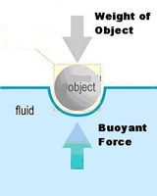
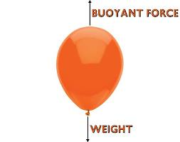

Objective:
- Define buoyant force
- Predict whether the buoyant force (in water) will be greater than the gravity force (weight) of two objects.
- Connect the buoyancy of objects in water to the buoyancy of objects in the air.

Define:
- Use the following websites to help define what is meant by buoyant force. Then, write a definition In your own words
  - http://www.merriam-webster.com/dictionary/buoyant%20force
  - https://simple.wikipedia.org/wiki/Buoyancy

Buoyant Force (in your own words) -

Measure:
- Use the electronic scale to measure the weight, in grams, of a Ping-Pong ball and a golf ball. Enter your results in the table below.
Object | Volume (ml) | Weight (grams) | Greater Force (Gravity or Buoyancy?) | Float or Sink?
Water | 40 | 40 | ------ | -----
Ping-Pong Ball | 40
Golf Ball | 40
Water Balloon | 40 | 40

Predict:
- Based on the weight of the balls as compared to the weight of water, which is greater for the object, the buoyant force, or gravity force? (Answer in the table above)

- Predict whether each ball will float or sink. (Table)

Experiment:
- Place each ball in a glass of water. Observe the results.

Conclusion:
- Explain why one ball floats, while the other sinks.

- How does this experiment in water relate to hot air balloons in the air?

