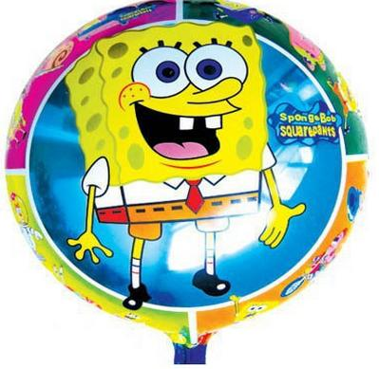
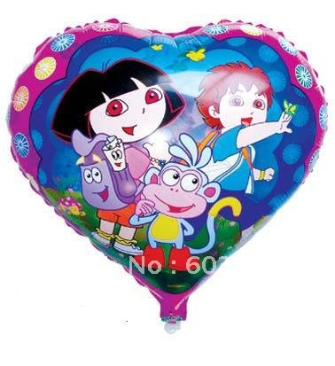
Neutral Buoyancy
Balloon Challenge

Neutral buoyancy is a condition in which an object’s density is equal to the density of the fluid in which it is immersed. The buoyancy force balances the force of gravity that would otherwise cause the object to sink. An object that has neutral buoyancy will neither sink nor rise.
1. Design a basket:
- Follow directions for making a paper basket on one of the following websites, or find your own style and directions.
  - http://craftyjournal.com/easy-paper-basket/
  - http://www.homemade-gifts-made-easy.com/paper-easter-basket.html
  - (more difficult) http://www.mathematische-basteleien.de/basket.htm
- Name your balloon and add this to your basket.
- Decorate or color your final basket.

2. Design your characters:
- Use Photobooth to take headshots of each of your team members.
- Put images onto one document, each should be about the size of a quarter.
- Get approval, and print in color.
- By hand, draw and color a paper body for your headshot.

3. Weigh your basket and occupants:
- Using the electronic scale, measure the weight, in grams, of your paper basket and team characters.
- Record your weight.

4. Achieve neutral buoyancy:
- Attach your basket to your balloon.
- Using paperclips as ballast, add weight to your basket until your balloon’s weight is perfectly balanced (not rising or falling)… neutral buoyancy!
- Record the weight added. Calculate the total weight (lifting force).

5. Compete in Neutral Buoyancy Challenge:
- Line up with the other competitors.
- Hold your balloons roughly 4 feet off the floor.
- On the count of three, release your balloons.
- The last balloon to touch the floor or ceiling wins!

GOOD LUCK!!

